A Comparative Analysis of Statistical, Machine Learning, and Deep Learning Models for Electricity Demand Forecasting

Student Name: Anil Kumar Chava
Student ID: 24068000

Table of Contents
1. Introduction 1
2. Data and Preprocessing 1
3. Exploratory Analysis 2
4. Forecasting Methods 3
5. Evaluation Design 4
6. Results 5
7. Error Analysis 6
8. Discussion 6
9. Limitations 7
10. Conclusion 7
11. References 8
Appendix: Github Repository Link 9

List of Figures
Figure 1 Dataset and exploration result 2
Figure 2 ACF and PACF plots 3
Figure 3 QQ plot and correlation Heatmap 3
Figure 4 Forecasting Result 4
Figure 5 Pipeline Models Evaluation result 5

1. Introduction
The electricity demand forecasting is vital for the smooth and efficient operation of electricity systems by supporting their operational planning, electricity generation and electricity distribution. Precise forecasts allow energy providers to match the timing of energy consumption with energy availability, consequently minimising energy usage and costs, as well as stabilising the grid. The task of building accurate forecasting models is growing in significance because of changes in electricity consumption over time, such as those associated with seasons and people's activities.
Machine learning and deep learning have opened new doors of opportunities to enhance forecasting accuracy compared to the traditional statistical methods. These methods have been capable of modelling complex temporal patterns from the past consumption data in the electricity domain and have shown good results in energy forecasting (Sedai et al., 2023).
This project takes a complete pipeline approach to electricity demand forecasting based on a public dataset of hourly electricity demand. The study conducts data cleaning, exploratory data analysis, feature engineering and forecasting processes with benchmark modelling, statistical modelling, machine learning and deep learning models (Perçuku et al., 2025). Each model’s forecasting accuracy is tested and compared by using several regression metrics to determine the best model to predict electricity demand.

2. Data and Preprocessing
The official dataset of hourly electricity demand observations, called time_series_60min_singleindex, was used for the study. This dataset was 50401 rows long, with 300 columns. Only the variable of electricity demand was chosen for forecasting in pre-processing. The date was converted to datetime format, which was then used as the dataframe index, resulting in a filtered dataframe of 50,400 data points per hour. A data quality assessment revealed no missing data but found 23,031 duplicate rows which were left in the data because they showed the chronological order (Pannakkong et al., 2022).
Some feature engineering was then done to achieve an enhanced forecasting performance. The following variables were constructed: Calendar variables, lag variables, rolling means, rolling standard deviations and cyclical sine and cosine changes. Other data sets were automatically generated at hourly, daily, weekly, monthly and annual resolutions (Aswanuwath et al., 2023). The final modelling data set was composed of 50,232 points, having retained the rows in the data table that were influenced by the creation of a lag and 33 predictive features.
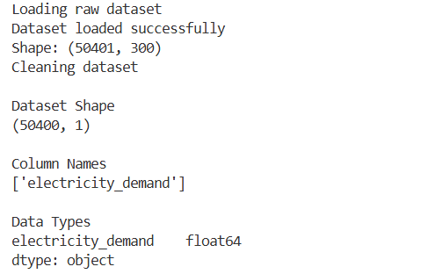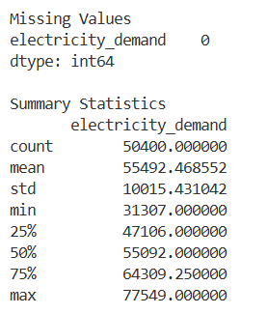
Figure 1 Dataset and exploration result
How leakage was avoided
Data leakage was prevented by constructing lag and rolling features using only historical electricity demand values. Rather, lag variables were constructed solely based on past electricity demand values. No observations were used to train the model, all observations are feature engineered during that time and the last 104 observations are left out of the model training and only used to test the model. It was done to eliminate leakage of data by splitting the time series.

3. Exploratory Analysis
Before model development, Exploratory Data Analysis (EDA) was used to understand the characteristics of the electricity demand. Summary statistics indicated that there were no missing data, while the average demand value for the cleaned data was equal to 55,492.47 MW. Time-series plots, distribution plots, boxplots and monthly/yearly/weekday/hourly patterns were created to explore the time-series patterns of electricity demand over the course of the time period covered.
Additional statistical analyses performed were seasonal decomposition, rolling mean/rolling std analysis, correlation heat maps, ACF and PACF plots, QQ plots and stationarity tests with the ADF and KPSS tests. The analyses showed that there were strong seasonal characteristics and temporal dependence in the data that supported the use of statistical, machine learning, and deep learning forecasting models for further forecasting tasks (Grandon et al., 2024).
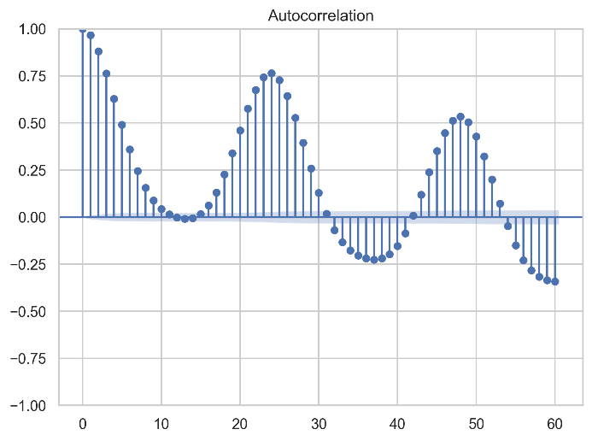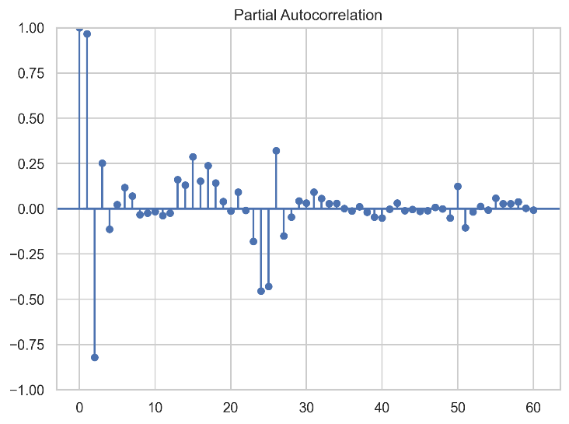
Figure 2 ACF and PACF plots

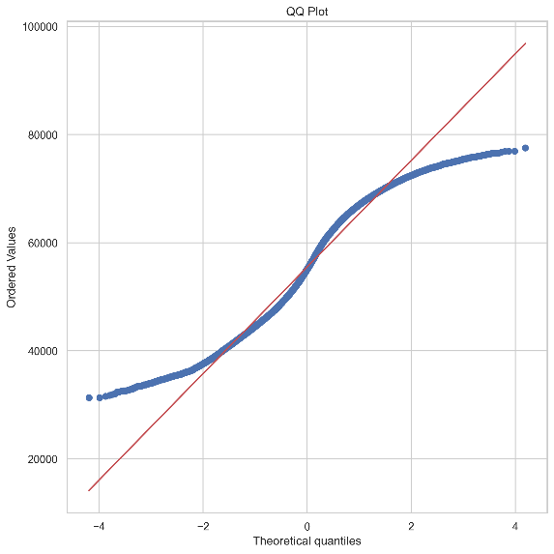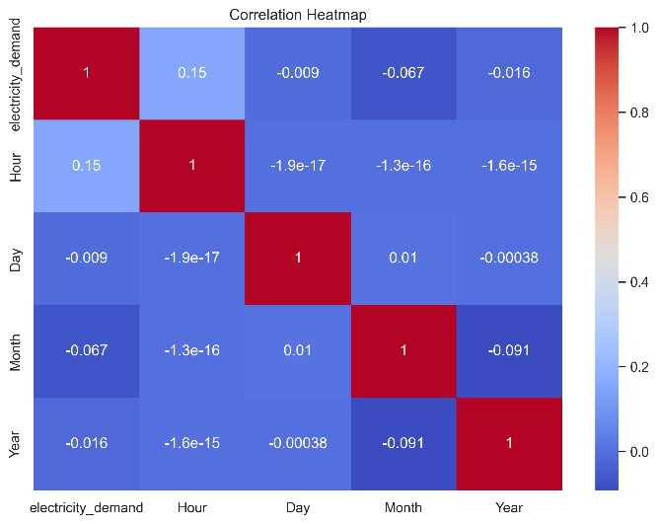
Figure 3 QQ plot and correlation Heatmap

4. Forecasting Methods
Five forecasting models used were compared for forecasting effectiveness. Baseline forecasting models used were mean, naïve, seasonal naïve and drift models. Then a SARIMA model was developed using auto parameter selection to capture the seasonal behaviour of the electricity demand series. To test the statistical model performance, the forecasts, confidence intervals, residual plots and residual distributions were produced.
The engineered temporal features were used in feature-based forecasting, which was done with the Random Forest, the Gradient Boosting and the Bayesian Ridge Regression algorithms. In addition, an LSTM deep learning model was developed with the application of the min-max normalisation method and sequential input windows (Irfan et al., 2023). The network was trained for five epochs with a learning rate reduction and Adam optimiser and was trained with early stopping. Each model was tested with the same data and standard performance criteria to make the test results comparable.
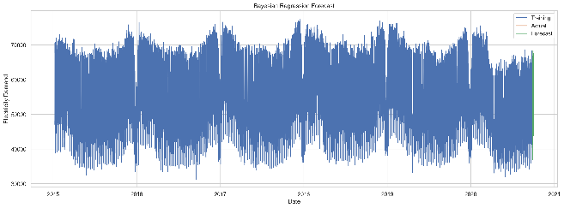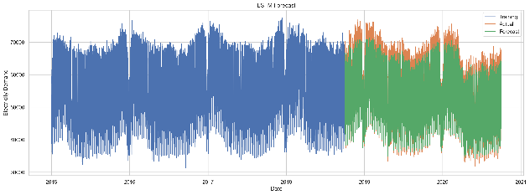
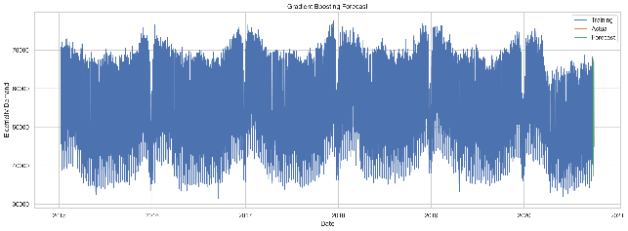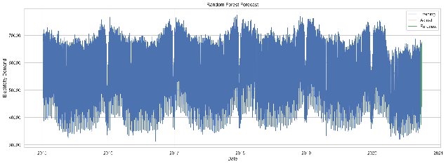
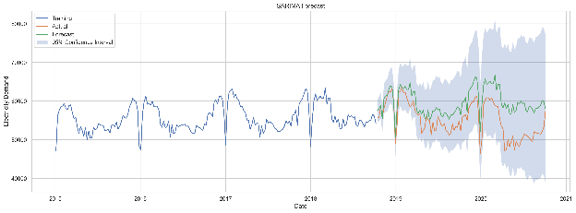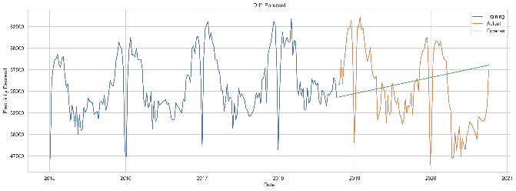
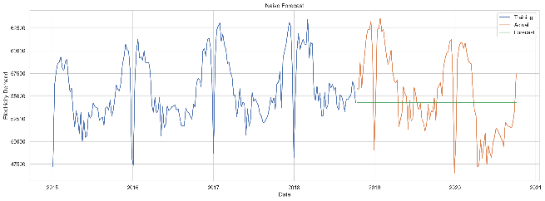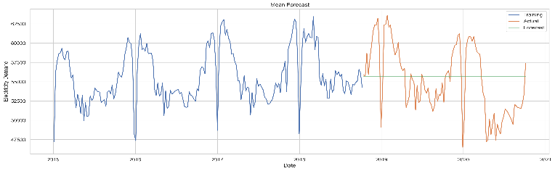
Figure 4 Forecasting Result

5. Evaluation Design
All forecasting models have been fairly compared using a consistent evaluation framework. The data set was divided chronologically into training and testing sets; the last 104 were used for testing, and all the other data sets were used for model training. This left the order of the data unchanged and did not introduce information leakage, which allowed simulating realistic forecasting conditions.
Model performance was assessed with RMSE, MAE, MAPE, MSE, R² and bias for comparisons of the prediction accuracy of all the models. Plots of forecasts were created for each model, along with SARIMA residual plots, Random Forest plots of feature importance, Gradient Boosting plots of feature importance, and LSTM plots of the training loss (Park and Yang, 2024). This mixture of the numerical and graphical approaches enabled an in-depth evaluation of the accuracy of forecasts and the characteristics of the models.

6. Results
Results of forecasting demonstrated all the models were not equally effective. Among all the models, the Random Forest model had the highest accuracy of 469.23, MAE of 378.55, MAPE of 0.70% and R² of 0.9974, which are the best among all models. Gradient Boosting ranked next, closely behind, with an RMSE of 512.51 and an R² of 0.9969, while Bayesian Ridge Regression performed well with an RMSE of 876.15 and an R² of 0.9910.
The machine learning models showed better performance in terms of accuracy, with the RMSE equal to 1765.24 and R² equal to 0.9545, which is fair but not as accurate as the LSTM model. The benchmark method that provided the highest baseline performance was Seasonal Naive, with an RMSE of 3569.93, a MAPE of 2.65%, and an R² of 0.9963. The performance of SARIMA was the worst, with RMSE 5372.87, MAPE 8.57% and R² −0.5110, while the best was Seasonal Naïve, with RMSE 3569.93, MAPE 2.65% and R² 0.9963. Ensemble models of machine learning were overall superior to statistical and deep learning methods.
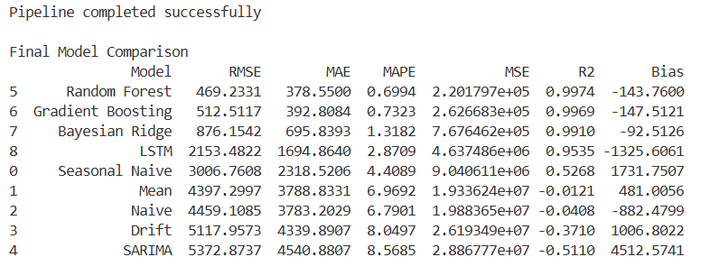
Figure 5 Pipeline Models Evaluation result
Compare all models against the Seasonal Naïve benchmark.
The baseline model was the Seasonal Naïve model with RMSE 3006.76. These four models (Random Forest, Gradient Boosting, Bayesian Ridge and LSTM) performed better than the Seasonal Naïve benchmark (8966.54). The Random Forest model resulted in the largest decrease, with an RMSE drop of about 84% from the baseline. To the contrary, SARIMA model showed an RMSE of 5372.87, which is lesser than Seasonal Naïve model.

7. Error Analysis
Forecast plots and evaluation metrics for all forecasting models were compared, and error analysis was done. Random Forest and Gradient Boosting had the lowest prediction errors and deviated less from the actual electricity demand during the testing period. The low values of RMSE and MAE highlight the successful capturing and modelling of seasonal trends and nonlinear relationships from the dataset via the engineered temporal features (Mathumitha et al., 2024).
In comparison, the linear modelling assumptions of the Bayesian Ridge Regression led to a slight increase in errors, while the LSTM model failed to predict some peaks of demand despite having the highest number of training epochs of 5. The SARIMA model made the largest errors of prediction, as it was not suitable for such a complex, non-linear series for predicting the electricity demand. The result obtained here is verified: the forecasts can be obtained most accurately and reliably using the feature-based ensemble method for the selected data set.

8. Discussion
The outcomes show that modelling methods can significantly affect the predictability. Random Forest showed the best results with an RMSE of 469.23, MAE of 378.55, MAPE of 0.70% and R² of 0.9974, while Gradient Boosting was right on their heels with an RMSE of 469.26, MAE of 378.56, MAPE of 0.70% and an R² of 0.9974. Their accuracy is generally better, primarily because of the use of ensemble learning and feature engineering, facilitating the models to learn nonlinearity and the seasonal trends in the electricity demand datasets better than the other methods used for forecasting.
The LSTM model was the most successful but faltered on accuracy terms, as it successfully learnt temporal patterns throughout training. Although Bayesian Ridge Regression resulted in good accuracy, LSTM was less successful on successful accuracy terms as it learnt temporal patterns during training. Traditional statistical approaches like the benchmark models and SARIMA produced the greatest errors in forecasting with this data, indicating that it was better suited for statistical methods (Aswanuwath et al., 2023). The overall conclusion is that machine learning models based on features are the most accurate solution to the hourly electricity demand forecast problem.
Compare the interpretability and complexity of SARIMAX, feature-based, and neural network models.
SARIMA is the most interpretable of the models as the moving-average, differencing and autoregressive terms can all be analyzed directly, but only if there are linear relationships. Feature based machine learning models offer some level of interpretability (the feature importance) and perform well when modelling nonlinear relationships. The LSTM (long short-term memory) model is the most complicated one, as it is a black-box model and more computers are needed to run this model, yet it automatically learns the sequential patterns.

9. Limitations
The engineered pipeline went through a process of grafting a digital pipeline back to the set of analogue sensors – with high prediction accuracy; however, there were some limitations. The models were built with historical electricity demand data only, and no external factors like weather data, public holidays or economic indicators have been taken into account, which have the potential to affect electricity demand. Feature engineering was also largely performed via calendar, lag, rolling and cyclical variables, and advanced feature extraction techniques were not explored (Sedai et al., 2023).
To minimise training time, the LSTM model was trained for just 5 epochs and compared to a comparatively simple network architecture. There is a potential for a deeper neural network or combinations of networks, or a more extensive hyperparameter tuning for further improvement. Last, the model's evaluation was performed on one split of the chronological test, whereas the rolling test, which may offer a more holistic evaluation of the model's forecasting robustness, was not used (Park and Yang, 2024).

10. Conclusion
The aim of this project was to develop a full electricity demand forecasting pipeline that includes statistical, machine learning and deep learning methods. Successfully incorporated a full electricity demand forecasting pipeline that includes statistical, machine learning and deep learning methods. This involved data preprocessing, exploratory analysis, creating features, model development, model evaluation and the automatic generation of visualisations, metrics, trained models and forecasts. Implementation gave a fully reproducible one for analysing hourly electricity demand in the time_series_60min_singleindex dataset.
The results of this performance comparison indicated that the accuracy of forecasting of the models LSTM, benchmark models and SARIMA was relatively low compared to the models Random Forest, Gradient Boosting and Bayesian Ridge Regression. The observations show that using an ensemble machine learning method with suitable feature engineering resulted in the highest accuracy forecasting prediction and can serve as a significant base for future work in the field of forecasting electric demand.
Recommend one model for operational use and justify the choice using accuracy, uncertainty, interpretability, and maintenance considerations.
Based on the best forecasting capability, the RMSE of 469.23, the MAE of 378.55, the MAPE of 0.70% and the R² of 0.9974, the RF is recommended for the operational use. It is less of a compute costs burden than LSTM, is easy to maintain and gives explanation for features. SARIMA did generate confidence bands but the forecasts were noticeably inaccurate. Hence, there is a balance between accuracy and interpretability and practicability in terms of operational use of Random Forest.

11. References
Aswanuwath, L., Pannakkong, W., Buddhakulsomsiri, J., Karnjana, J. and Huynh, V.N., (2023). A Hybrid Model of VMD-EMD-FFT, Similar Days Selection Method, Stepwise Regression, and Artificial Neural Network for Daily Electricity Peak Load Forecasting. Energies, 16(4), p.1860. Available at: https://www.mdpi.com/1996-1073/16/4/1860
Grandon, T.G., Schwenzer, J., Steens, T. and Breuing, J., (2024). Electricity demand forecasting with hybrid classical statistical and machine learning algorithms: Case study of Ukraine. Applied Energy, 355, p.122249. Available at: https://www.sciencedirect.com/science/article/pii/S0306261923016136
Irfan, M., Shaf, A., Ali, T., Zafar, M., Rahman, S. and Mursal, S.N.F., (2023). Multi-region electricity demand prediction with ensemble deep neural networks. PLOS ONE, 18(5), e0285456. Available at: https://journals.plos.org/plosone/article?id=10.1371/journal.pone.0285456
Mathumitha, R., Rathika, P. and Manimala, K., (2024). Intelligent deep learning techniques for energy consumption forecasting in smart buildings: A review. Artificial Intelligence Review, 57, p.35. Available at: https://link.springer.com/article/10.1007/s10462-023-10660-8
Pannakkong, W., Harncharnchai, T., and Buddhakulsomsiri, J. (2022). Forecasting Daily Electricity Consumption in Thailand Using Regression, Artificial Neural Network, Support Vector Machine, and Hybrid Models. Energies, 15(9), 3105. https://doi.org/10.3390/en15093105
Park, M.J. and Yang, H.S., (2024). Comparative study of time series analysis algorithms suitable for short-term forecasting in implementing demand response based on AMI. Sensors, 24(22), p.7205. Available at: https://www.mdpi.com/1424-8220/24/22/7205
Perçuku, A., Minkovska, D. and Hinov, N., (2025). Enhancing electricity load forecasting with machine learning and deep learning. Technologies, 13(2), p.59. Available at: https://www.mdpi.com/2227-7080/13/2/59
Sedai, A., Dhakal, R., Gautam, S., Dhamala, A., Bilbao, A., Wang, Q., Wigington, A. and Pol, S., (2023). Performance analysis of statistical, machine learning and deep learning models in long-term forecasting of solar power production. forecasting, 5(1), pp.256-284. https://www.mdpi.com/2571-9394/5/1/14

Appendix: Github Repository Link
Please check here for the all code input and output is deploy here:
https://github.com/chavaanilkumar/electricity-load-forecasting

